ministry of education and science of RF

Russian academy of sciences

national academy of sciences of KR

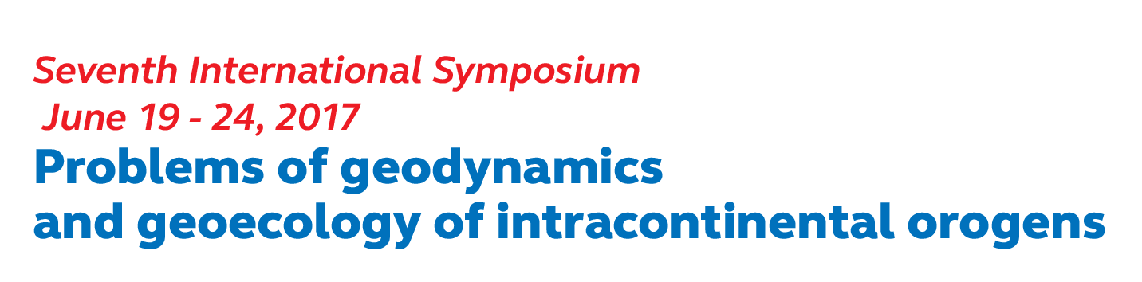

**Bishkek, Kyrgyzstan**

**19 – 24 June, 2017**

*FIRST CIRCULAR*

***Organizers of Symposium:***

* Department of the Earth’s Sciences, RAS
* Research Station RAS in Bishkek, KR
* International Research Center – Geodynamic Proving Ground in Bishkek, KR
* Institute of Geomechanics and Mineral Exploration, NAS, KR
* Institute of Geology, NAS, KR
* Institute of Seismology, NAS, KR
* Interdepartmental Tectonic Committee under the Department of the Earth’s Sciences, RAS, RF
* Geological Institute, RAS, RF
* Schmidt Institute Physics of the Earth, RAS, RF
* Federal Research Center “Common Geophysical Service of RAS”, RF
* Kyrgyz-Russian Slavic University, KR
* Trofimuk Institute of Oil-and-Gas Geology and Geophysics, Siberian Branch of RAS, RF

***Objective of Symposium:***

To discuss the state of problems and results of research in Geodynamics and Geoecology of intracontinental orogens including problems of lithosphere structure formation, development of methods, technologies and means of studying of Earth’s surface and interior, social and economic consequences of endogenous and exogenous disastrous processes..

***Languages of Symposium:***

Russian, English.

***Organizations responsible:***

* Research Station RAS in Bishkek city, Kyrgyz Republic;
* International Research Center – Geodynamic Proving Ground (IRC – GPG)

**ORGANIZING COMMITTEE OF SYMPOSIUM**

***Chairman:***

Alexandr Gliko (Russia)

***Co-chairmen:***

Altai Borubaev (Kyrgyzstan)

Aleksei Gvishiani (Russia)

Mikhail Epov (Russia)

***Vice-chairman:***

Kamchybek Kozhogulov (Kyrgyzstan)

Anatoly Rybin (Russia)

Gennady Schelochkov (Russia)

***Academic secretaries:***

Olga Zabinyakova (Russia)

Konstantin German (Russia, Kyrgyzstan)

Alla Fortuna (Kyrgyzstan)

***Organizing committee members:***

Aleksei Lopatin (Russia)

Tanatkan Abakanov (Khazakstan)

Kanatbek Abdrakhmatov (Kyrgyzstan)

Pavel Alexandrov (Russia)

Yuri Antonov (Russia)

Apas Bakirov (Kyrgyzstan)

Leonid Bogomolov (Russia)

Mikhail Buslov (Russia)

Ivan Varentsov (Russia)

Kirill Degtyarev (Russia)

Albert Duchkov (Russia)

Vladimir Zeigarnik (Russia)

Boris Levin (Russia)

Valery Lelevkin (Russia, Kyrgyzstan)

Mikhail Leonov (Russia)

Aleksei Malovichko (Russia)

Petr Martyshko (Russia)

Yuri Morozov (Russia)

Kadyrbek Sakiev (Kyrgyzstan)

Victor Seleznev (Russia)

Gennady Sobolev (Russia)

Nikolai Sharov (Russia)

Jacques Zlotnicki (France)

Koji Suzuki (Japan)

Peter Molnar (USA)

Nikolaos Sarlis (Greece)

Qinghua Huang (China)

Oliver Ritter (Germany)

Steven Roecker (USA)

Toshiyasu Nagao (Japan)

***Local committee***

Sergei Druzhinets

Olga Borisova

Elena Khalmurzina

Natalia Petkus

***Program committee***

Kanatbek Abdrakhmatov (Kyrgyzstan)-*Chairman*

Mikhail Buslov (Russia)

Yuri Morozov (Russia)

Olga Nikolskaya (Kyrgyzstan)

Inna Sokolova (Khazakstan)

The Seventh International Symposium “Problems of Geodynamics and Geoecology of Intracontinental Orogens” is dedicated to 80th Anniversary of the birth of outstanding scientist, founder and the first director of Research Station RAS – Trapeznikov Yu. A. (18.10.1936 – 13.04.1999).

**SYMPOSIUM THEMES**

* Deep structure and evolution of the Earth’s crust and upper mantle in the light of modern conceptions of Geodynamics. Instrumental methods of studying of intracontinental orogens lithosphere: heterogeneities, physical nature of boundaries.
* Stressed and deformed state of the Earth’s crust, problems of its block structure and selfsimilarity of geodeformation processes. Seismotectonics of intracontinental orogens zones.
* Complex monitoring of seismically active zones. Problems of geospheres interaction, including the influence of physical fields on endogenous processes.
* Electromagnetic methods in studying of seismically active regions and in monitoring of geodynamic processes. Development of inversion methods of electromagnetic data.
* Assessment of seismic risk, regional studies of seismic regime.
* Environmental and social consequences of endogenous and exogenous geological
* Processes, prediction of hazardous events (earthquakes, landslides, etc.).
* Exposition “Modern Developments of Software and Hardware Tools of Geodynamic Research”.

**REGISTRATION**

Application for participation in Symposium should be sent to email [**zabinyakova@gdirc.ru**](mailto:zabinyakova@gdirc.ru) **and copy to** [**ns_ran@mail.ru**](mailto:ns_ran@mail.ru) **till 15 February, 2017**. Registration form is attached.

**SYMPOSIUM LOCATION**

International Research Center – Geodynamic Proving Ground (IRC – GPG), Bishkek city, Kyrgyz Republic

**PUBLICATION OF MATERIALS**

The participants may submit to the Organizing Committee:

- abstract (thesis) of Report (no more than 1 page);

- extended abstract (no more than 4 pages).

**All materials should be submitted by e-mail**

**as attached files**

[**zabinyakova@gdirc.ru**](mailto:zabinyakova@gdirc.ru) **or** [**tua@gdirc.ru**](mailto:tua@gdirc.ru)

**and copy to**

[**ns_ran@mail.ru**](mailto:ns_ran@mail.ru)

Abstracts should be submitted in Russian or English **till 15 April 2017.** The Book of Reports will be published to the opening date of Symposium. Organizing Committee does not edit abstracts. Full version of Reports (to 7 pages) will be refereed, the issue of Book of Reports is scheduled for 2018.

***Organizing Committee reserves the right of oral reports and materials selection for publication.***

**SYMPOSIUM KALENDAR**

Final date of application acceptance – **till 15 of March, 2017**

Materials submission – **till 15 of April, 2017**

Sending out of second secular with tentative program – **till 1 of May, 2017**

Working days of Symposium – **19–24 of June 2017**

**CONTACTS:**

*Olga Zabinyakova*

E-mail: [zabinyakova@gdirc.ru](mailto:zabinyakova@gdirc.ru)

[ns_ran@mail.ru](mailto:ns_ran@mail.ru)

*Konstantin German*

E-mail: [air_storm@bk.ru](mailto:air_storm@bk.ru)

*Alla Fortuna*

E-mail: [alla-fortuna0@rambler.ru](mailto:alla-fortuna0@rambler.ru)

Address: Research Station RAS, Bishkek-49, 720049, Kyrgyz Republic

Fax: 996 (312) 61-14-59

Тel.: 996 (312) 61-31-40

All information on the event will be sent out to all interested in participation in Symposium and will be published on the website of Research Station RAS:

[**www.gdirc.ru**](http://www.gdirc.ru)**;** [**www.gdirc.kg**](http://www.gdirc.kg)

**Requirements to abstracts and papers**

1. Paragraph 1 (on top) - title of the abstract
2. Paragraph 2 - author (s)’ initials, surname (s), phone, fax, e-mail.
3. Paragraph 3 - full name of the institution, city, country.
4. Paragraph 4 – text of the abstract.
5. Paragraph 5 – numbered reference list (references in the text should be in the form [1,2-]).

**Format:**

1. Text edit – Microsoft Word
2. Page format – А4
3. Margins: top – 2 сm, bottom – 2 сm,  
    right – 1.5 сm, left –3 cm
4. Font – Times New Roman
5. Type size – 12
6. Lines with single spacing
7. Tabulation – 1 cm

**Registration fee**

**Registration fee** includes: meeting at the airport MANAS and delivery to the Symposium location, set of materials for Symposium participant, including Book of Reports and ticket to partner dinner.

1. For scientists from CIS (Commonwealth of Independent States), representing noncommercial organizations – $60
2. For foreign scientists – $100

Cost of **excursion** ticket (23 of June, 2016.):

1. For scientists from CIS (Commonwealth of Independent States), representing noncommercial organizations – $50
2. For foreign scientists – $100

**ACCOMMODATION OF GUESTS**

Accommodation of participants from another cities is planning in out-of-town hotels “Koi-Tash” and “Janat” (close to Proving Ground) or in hotels in Bishkek city. Cost of living for night for single suit varies from 25$ to 150$; for double suit – from 40$ to 150$. Please, specify your requests on accommodation in registration form (attached).

**FIELD GEOLOGICAL EXCURSION**

(24 June)

Organizing Committee plans one-day automobile and walking geological excursion to Ala-Archa Gorge.

Ala-Archa Gorge is situated in central and highest part of Kyrgyz Mountain Range (Tian Shan), at 40 km from Bishkek and is known as the most picturesque place in Kyrgystan. Ala-Archa sweeps away for 35 km. The landscape of gorge is diversified enough: there are both broad lands of piedmont steppes and thick greenery of mountain forests.

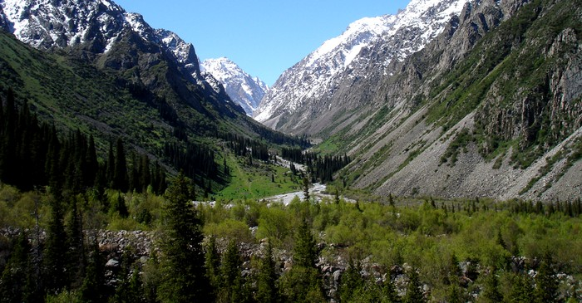

«Ala-Archa» means «colorful juniper». Archa is local name for juniper. Ala-Archa Gorge got its name ought to dense brushing of juniper which cover the slopes of mountains.

Your dress should be comfortable for field walk in the mountains (mountaineering boots or jogging shoes).

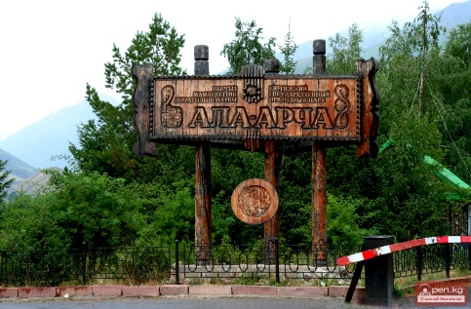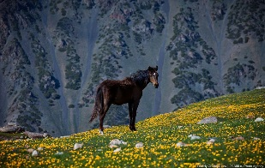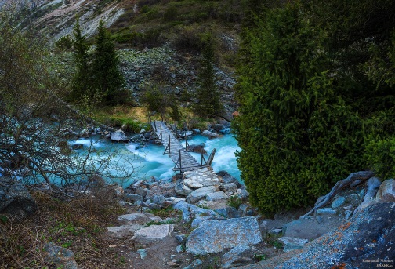

**REGISTRATION FORM**

Of the participant of Seventh International Symposium   
PROBLEMS OF GEODYNAMICS AND GEOECOLOGY OF INTRACONTINENTAL OROGENS

Bishkek city, Kyrgyz Republic

19–24 of June, 2017.

|  |  |
| --- | --- |
| Surname, Name |  |
| Academic degree, title |  |
| Name of organization |  |
| Position |  |
| Tel. number |  |
| E-mail |  |
| Title of scientific report |  |
| Information about each author: Surname, name., place of work or study (full name of organization , department: faculty, department, laboratory), postal address of organization, tel., e-mail | 1. |
| 2. |
| 3. |
| Number and title of RFBR project  (if your report is based on results obtained within research with financial support from Russian Foundation for Basic Research |  |
| Form of participation  (oral report,  Poster presentation,  listener) |  |
| Participation in the field excursion (Yes/No) |  |
| Hotel accommodation |  |

*Please do not hesitate to apply to*

*Academic secretary of RS RAS Zabinyakova Olga*

*on all questions connected with execution of reports*

Тел.: **+ 996 (312) 61-31-40**

**+ 996 (312) 61-14-59**

E-mail: [zabinyakova@gdirc.ru](mailto:zabinyakova@gdirc.ru)

ns_ran@mail.ru

[tua@gdirc.ru](mailto:tua@gdirc.ru)