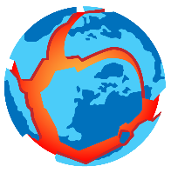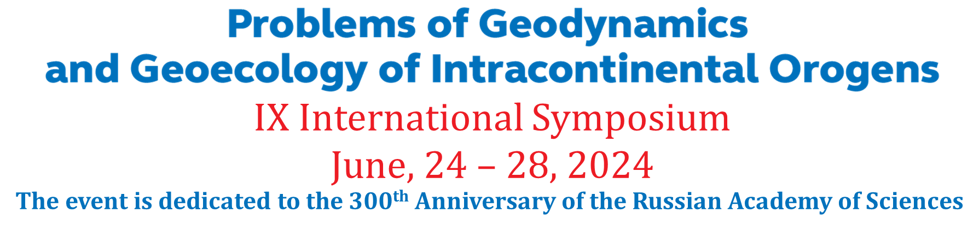

REGISTRATION FORM

First Name
Last Name
Academic degree
Academic title
Organization
Address
Country
Position
Phone number
e-mail
Section | Please, select one of the following Symposium directions which best of all matches your report area:  - Deep structure and evolution of the Earth’s crust and upper mantle in the light of modern conceptions of Geodynamics. Instrumental methods for the intracontinental orogens lithosphere studying: heterogeneities, physical nature of boundaries.  - Stress-strain state of the Earth’s crust, issues on its block structure and self-similarity of geodeformation processes. Seismotectonics of intracontinental orogens.  - Complex monitoring of seismically active zones. Problems of geospheres interaction, including the influence of physical fields on endogenous processes.  - Electromagnetic methods in studying of seismically active regions and in monitoring of geodynamic processes. Electromagnetic data inversion methods development.  - Seismic hazard assessment, regional studies of seismic regime.  - Ecological and social consequences of endogenous and exogenous geological processes, hazard events forecasting (earthquakes, landslides, etc.)
Title of scientific report
Information about coauthors: first name, last name, organization, position, address of organization, country, phone, e-mail  Please, mark if any of coauthors is a young scientists (till 39 years old) | 1.
 | 2.
 | 3.

In case of any questions do not hesitate to ask Olga Zabinyakova
Academic Secretary of the Research Station of RAS
Tel.: + 996 (312) 61-31-40; e-mail: ns_ran@mail.ru

