FEDERAL STATE BUDGETARY INSTITUTION OF SCIENCE – RESEARCH STATION
of the RUSSIAN ACADEMY OF SCIENCE in BISHKEK CITY (RS RAS)

INTERNATIONAL RESEARCH CENTER – GEODYNAMICAL PROOVING GROUND
in BISHKEK CITY (IRC-GPG)

RUSSIAN ACADEMY OF SCIENCES
(DEPARTMENT OF EARHT SCIENCES)

Dear colleagues!

IX International Symposium
“PROBLEMS OF GEODYNAMICS AND GEOECOLOGY OF INTRACONTINENTAL OROGENS”
will be held at Research Station of the Russian Academy of Sciences
in Bishkek city, Kyrgyz Republic, on 24 - 28 of June, 2024.
Executive organizers of Symposium:
- Research Station RAS in Bishkek, KR
- International Research Center – Geodynamic Proving Ground in Bishkek, KR
                - Objective of Symposium:
                - To discuss the state of problems and results of research in Geodynamics and Geoecology of intracontinental orogens including problems of lithosphere structure formation, development of methods, technologies and means of studying of Earth’s surface and interior, social and economic consequences of endogenous and exogenous disastrous processes.

                - Languages of Symposium:
Russian, English.
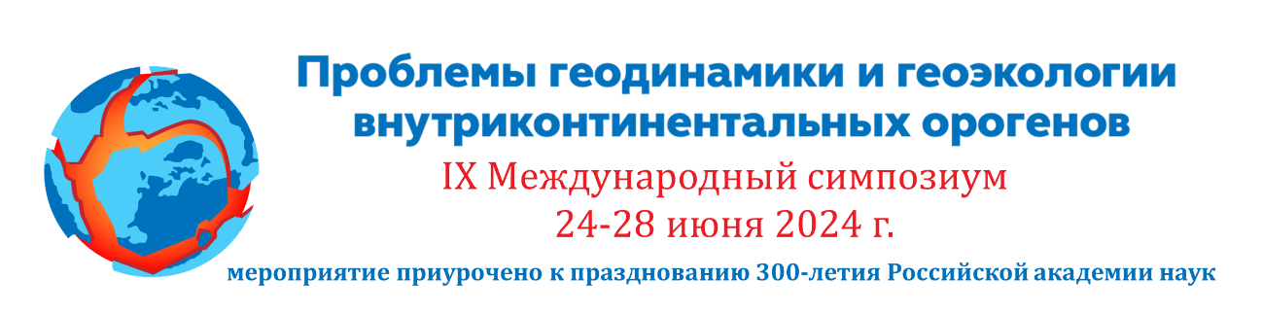
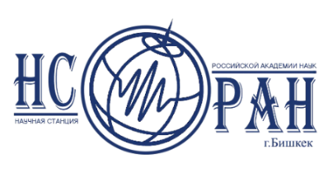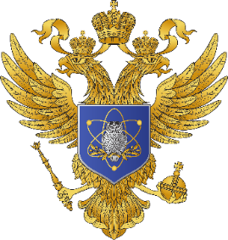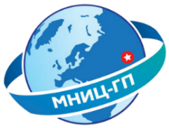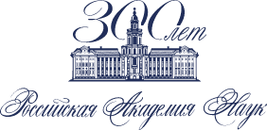

SYMPOSIUM THEMES

- Deep structure and evolution of the Earth’s crust and upper mantle in the light of modern conceptions of Geodynamics. Instrumental methods of studying of intracontinental orogens lithosphere: heterogeneities, physical nature of boundaries.
- Stressed and deformed state of the Earth’s crust, problems of its block structure and selfsimilarity of geodeformation processes. Seismotectonics of intracontinental orogens zones.
- Complex monitoring of seismically active zones. Problems of geospheres interaction, including the influence of physical fields on endogenous processes.
- Electromagnetic methods in studying of seismically active regions and in monitoring of geodynamic processes. Development of inversion methods of electromagnetic data.
- Assessment of seismic risk, regional studies of seismic regime.
- Environmental and social consequences of endogenous and exogenous geological processes, prediction of hazardous events (earthquakes, landslides, etc.).
- Exposition “Modern Developments of Software and Hardware Tools of Geodynamic Research”.

SYMPOSIUM KALENDAR
Sending out of first secular – till 01 of Jeniary 2024
Application and thesis submission – till 15 of April 2024
Sending out of second secular and the program – till 1 of June 2024
Working days of Symposium – 24 - 28 of June 2024

- Plenary and breakout sessions will be held in hybrid format.
- The registration form, abstracts requirements, registration fee information and other organizational issues will be detailed in the first circular.

Please do not hesitate to contact us:
Academic secretary of RS RAS
Zabinyakova Olga
Tel.: + 996 (312) 61-31-40
E-mail: ns_ran@mail.ru

All information about Symposium will be highlighted on the website
of RS RAN www.gdirc.ru, www.gdirc.kg

